Factory - PostgreSQL
Info-Gathering
of Azure Database for PostgreSQL - Single Server /
On-Premises / Azure VM / Other Cloud PostgreSQL workload to Azure Database for PostgreSQL - Flexible Server​ - User Guide



Disclaimer: These scripts are intended for use of Info Gather Assessment utility and do not interact with the user databases or gather any sensitive information (e.g. passwords, PI data etc.). These scripts are provided as-is to merely capture metadata information ONLY. While every effort has been made to ensure accuracy and reliability of the scripts, it is recommended to review and test them in a non-production environment before deploying them in a production environment. It is important to note that these scripts should be modified with the consultation of Microsoft.

Document Summary

Document Item | Current Value
Document Title | Factory - PostgreSQL Info-Gathering of Azure Database for PostgreSQL – Single Server / On-Premises / Azure VM / Other Cloud PostgreSQL workload to Azure Database for PostgreSQL - Flexible Server - User Guide
Program | Cloud Accelerate Factory
Date Last Modified | 22-Apr-2024
Date Last Reviewed | 22-Apr-2024
Status | Completed
Document Description | This document provides the procedure/steps to execute the Automation script which gathers the PostgreSQL Server details from Azure, Windows, and Linux environment.

Revision History

This section represents the change history of the document. Revisions of the document must be tracked by identifying a new version number, the date it was modified, the person making the change, and the reason for the change.

Date | Version | Change Description | Author | Reviewer
22-Apr-2024 | 1.0 | Initial draft | Chethan, Mukesh, Arun | Rackimuthu Kandaswamy, Sharad Khadtare

Table of Contents
1 Objective 5
2 Roles and Responsibilities 5
3 Pre-requisites for PostgreSQL Server Info gathering script execution 5
3.1 Operating System Requirements 5
3.2 Software requirements 5
4 Procedure 6
4.1 PostgreSQL Info-Gathering on Windows Server 6
4.1.1 Azure Database for PostgreSQL - Single Server Info-Gathering (Factory-PostgreSQL-CLI-Windows.ps1) 6
4.1.2 PostgreSQL Server Info-Gathering (Factory-PostgreSQL-Windows.ps1) 10
4.1.3 Automation Script Transcript Log 13
4.2 PostgreSQL Server Info-Gathering on Linux Server 14
4.2.1 Azure Database for PostgreSQL - Single Server Info-Gathering (Factory-PostgreSQL-CLI-Linux.ps1) 14
4.2.2 PostgreSQL Server Info-Gathering (Factory-PostgreSQL-Linux.ps1) 17
4.2.3 Export Info-Gathering details and generating output log files 19
4.2.4 Automation Script Transcript Logs 19
4.3 PostgreSQL Server Info-Gathering using Azure Cloud Shell 20
4.3.1 Scripts Folder 21
4.3.2 Preparing the INPUT File (Azure_Subscription.csv) 22
4.3.3 Script execution (Factory-PostgreSQL-Linux.ps1) 22
5 Appendix 26
5.1 Checking Error Logs 26
5.2 Troubleshooting 26
5.3 Input CSV File – Azure_Subscription.csv 27
5.4 Input CSV File - Factory-PostgreSQL_Server_Input_file.csv 28
5.5 Without Internet access to the URLs 29
5.6 Installing Azure CLI for Windows and Linux 30
5.7 PowerShell Version & Execution policy 30
5.8 PowerShell Installation on Linux 30
5.9 Adding psql (Postgres) as an environment variable in Windows 31
5.10 Adding Azure CLI as an environment variable in Windows 34

Objective
This document provides the procedure/steps to execute the Automation script (Factory-PostgreSQL-Windows.ps1, Factory-PostgreSQL-Linux.ps1, Factory-PostgreSQL-CLI-Windows.ps1, Factory-PostgreSQL-CLI-Linux.ps1) which gathers the PostgreSQL instance details from Azure, Windows, and Linux environment.

Note: The Automation Scripts does not fetch/access any of the user database data. The values present in the Screenshots are demo values. Please change the values as Appropriate.

Roles and Responsibilities
Task | Responsible | Accountable | Consulted | Informed
Info-Gather | Customer/Factory | PM | Factory | PM/Factory

Pre-requisites for PostgreSQL Server Info gathering script execution

Operating System Requirements
- Supported Operating System
- Windows - Windows 10, Windows Server 2012, Windows Server 2012 R2 and above
- Linux - RHEL v7 & above, Ubuntu v7 & above

Software requirements
- Azure CLI (To gather Azure Database for PostgreSQL Single Server metadata)
- PostgreSQL Client 11 and above
- PowerShell 5.1 and above.

Procedure

PostgreSQL Info-Gathering on Windows Server

Azure Database for PostgreSQL - Single Server Info-Gathering
(Factory-PostgreSQL-CLI-Windows.ps1)

Scripts Folder
- Unzip the Info-Gather-PostgreSQL zip file received by Factory Team

Preparing the INPUT CSV File - Azure_Subscription.csv
- In order to support the Info Gathering process, INPUT CSV FILE (Azure_Subscription.csv) should be provided with Azure Subscription data.
- Each column will represent an Azure Subscription detail for Azure PostgreSQL Single Server Info Gathering
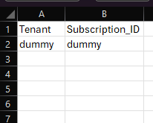

Script execution (Factory-PostgreSQL-CLI-Windows.ps1)
- Open windows Command prompt as Administrator
- Change the working directory/folder to the folder PostgreSQL-Info-Gather where the scripts are present.
- Enter the following command on windows command prompt to execute the info-gather script.

powershell.exe -ExecutionPolicy Bypass -File .\Factory-PostgreSQL-CLI-Windows.ps1

Create support folders (Logs, Output, Downloads etc)
- After triggering the automation all the support folders (Logs, Output, Download etc.) will be created automatically by the automation script in the PostgreSQL-Info-Gather folder
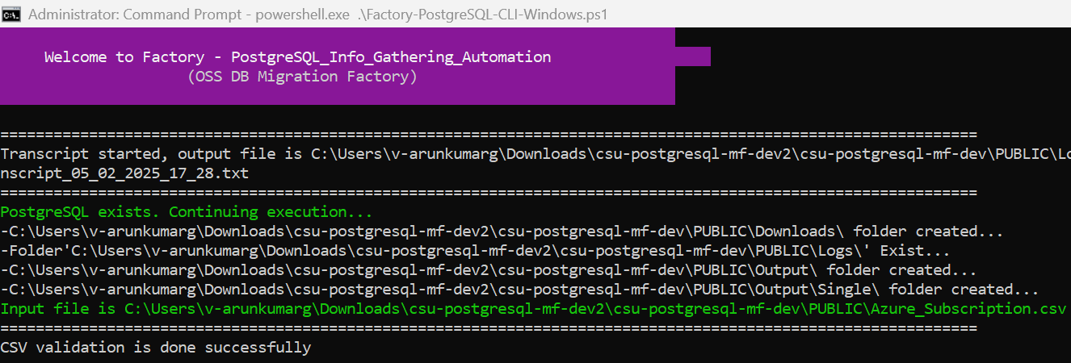

Validate Azure CLI
- Automation script validates if the Azure CLI application is installed. If it is not installed, you will have to install it manually via a link provided on the output screen.
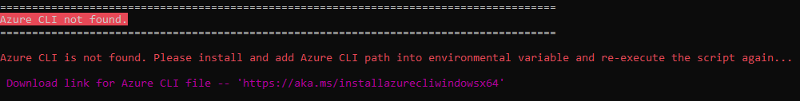
- Once Azure CLI Installation is complete, ensure the installation path is added to the environmental variables. Kindly close the Command Prompt and validate Azure CLI by re-running the automation script again.

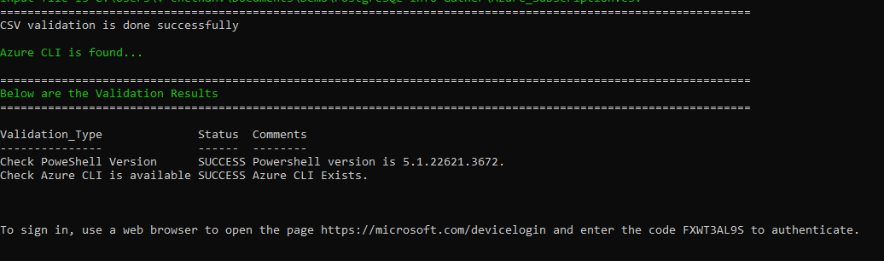
- PowerShell version and Azure CLI are validated successfully.

Azure Portal authentication
- Automation requires the Azure portal authentication. Use the provided URL and code to authenticate

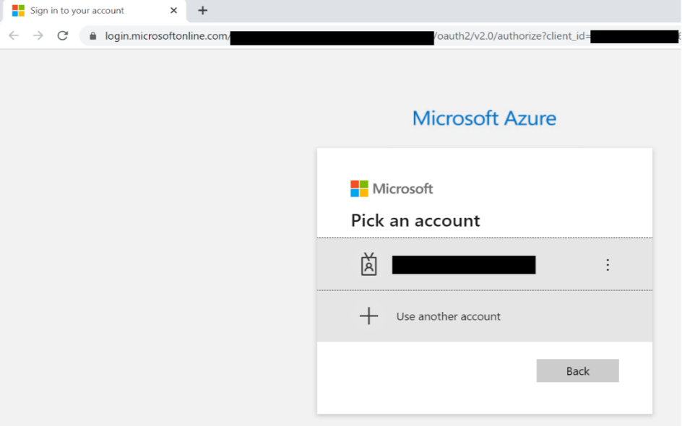

Export Info-Gathering details and generating JSON files
- Once Azure portal authentication is successful, Automation gathers Azure PostgreSQL Single Server details to update them in csv files. Also, Azure CLI’s PostgreSQL commands output will be exported to JSON file.
- The JSON files can be found in the Folder Output Single

Azure PostgreSQL Single Server JSON output
- The Following JSON output file will be generated and contains the list of all Azure PostgreSQL Single Server from the given Azure subscription(s).
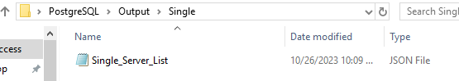

Azure PostgreSQL Single Server CSV output
- CSV files will be generated for all the PostgreSQL Single Server/Instance(s) from the given Azure subscription. Azure CLI’s output is as follows, 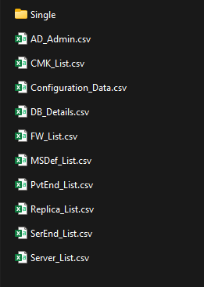 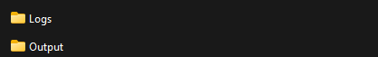

Automation Script Transcript Log
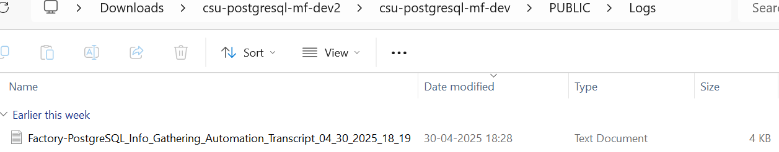

Note: For the Automation, transcript will be generated in text format as shown above

PostgreSQL Server Info-Gathering (Factory-PostgreSQL-Windows.ps1)

Preparing the INPUT CSV File -
(Factory-PostgreSQL_Server_Input_file.csv)
- To support the Info Gathering process, INPUT CSV FILE
(Factory-PostgreSQL_Server_Input_file.csv) should be provided with PostgreSQL Server details.
- Provide the Mandatory fields highlighted in red color as shown below.
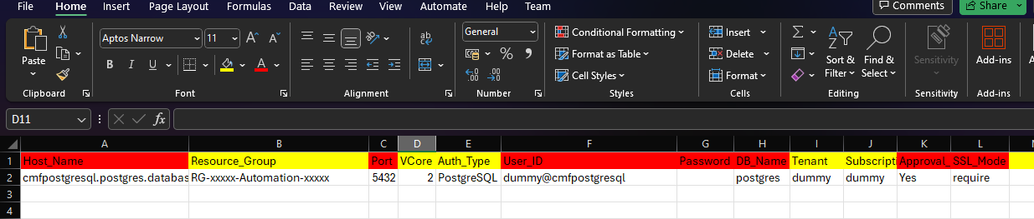

Script execution (Factory-PostgreSQL-Windows.ps1)
- Open windows Command prompt as Administrator
- Change the working directory/folder to the folder PostgreSQL-Info-Gather where the scripts are present.
- Enter the following command in the windows command prompt.
Powershell.exe -ExecutionPolicy Bypass -File .\Factory-PostgreSQL-Windows.ps1
- To securely store password and use it for info-gathering process, enter option ‘0’.
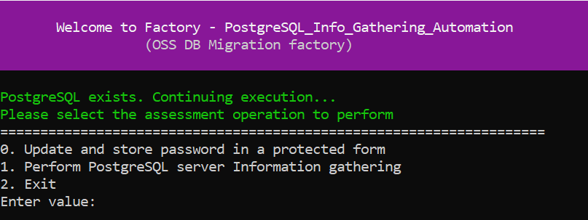
- To perform PostgreSQL server Information gathering, enter option ‘1’.
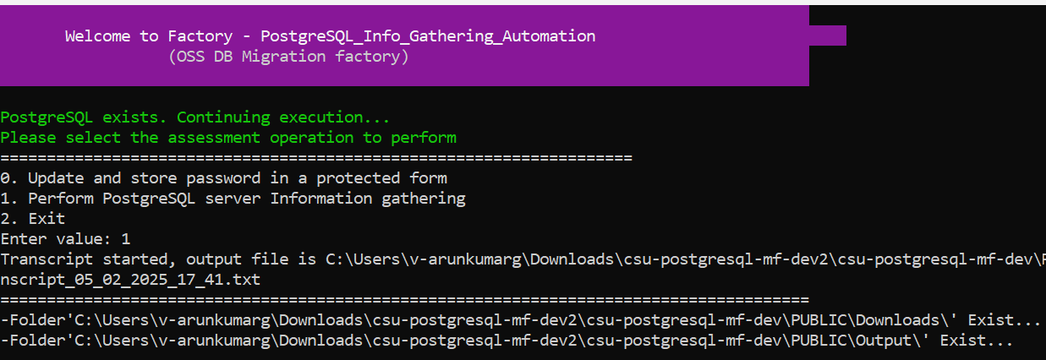
Note: After triggering the automation all the support folders (Logs, Output, Downloads etc.)
will be created automatically by the automation script, psql path is validated, and it will ask user to proceed with the execution of the script
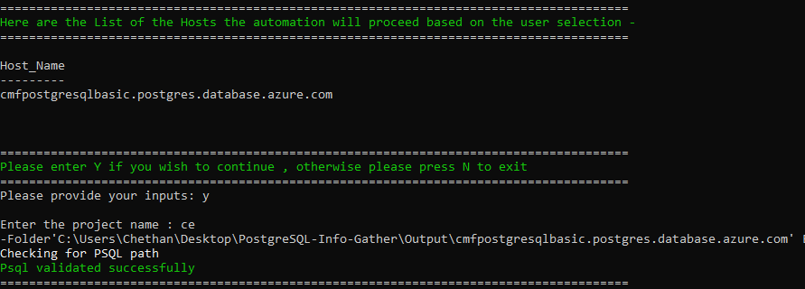
- The script then validates the list of Hosts to proceed with execution. Continue by Entering “Y” and provide your Project Name. You’ll get below the Final Status of the Script Execution.
Note: Ensure you add the location of psql.exe to your Path environment variables

- Provide the password for the username for each server when prompted like below:
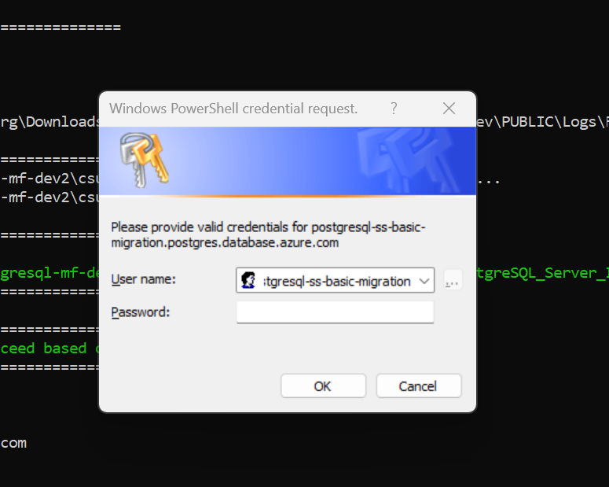

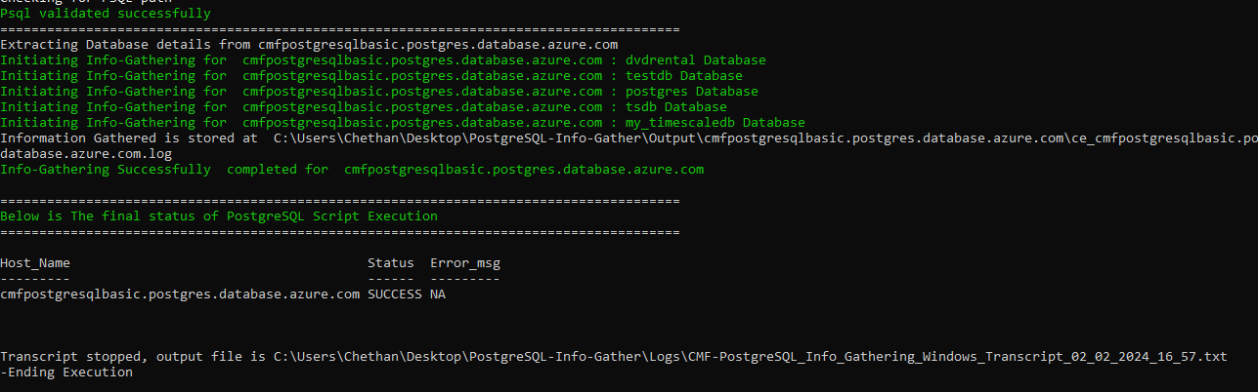

Export Info-Gathering details and generating output log files
- Output log files are generated for each PostgreSQL Server as shown in the below Output Folder.

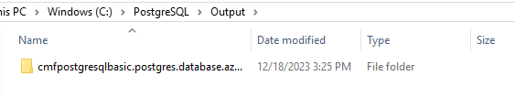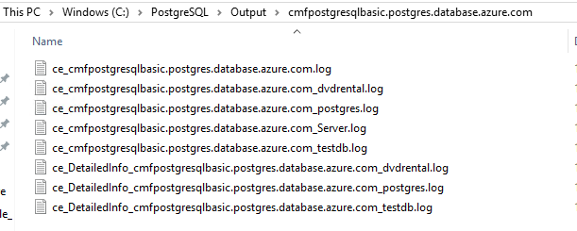

Automation Script Transcript Log

Note: For the Automation, transcript will be generated in text format as shown above
Note:
- Output files generated using Factory-PostgreSQL-CLI-Windows.ps1 and the log files generated by Factory-PostgreSQL-Windows.ps1 will be in the same Output and Logs folder.
- Please share compressed Output & Logs folder with Factory Team.

PostgreSQL Server Info-Gathering on Linux Server

Azure Database for PostgreSQL - Single Server Info-Gathering
(Factory-PostgreSQL-CLI-Linux.ps1)

Scripts Folder
- Unzip the PostgreSQL-Info-Gather zip file received by Factory Team
Commands: unzip PostgreSQL-Info-Gather.zip
cd PostgreSQL-Info-Gather /
ls -lrt

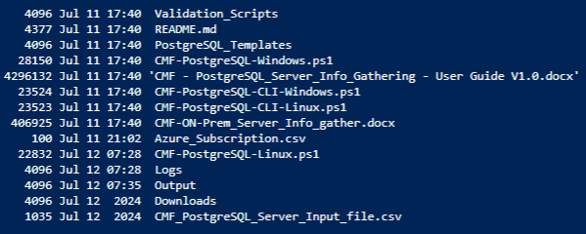

Preparing the INPUT CSV File - Azure_Subscription.csv
- To support the Info Gathering process, INPUT CSV FILE (Azure_Subscription.csv) should be provided with Azure Subscription data.
- Each column will represent an Azure Subscription detail for Azure PostgreSQL Single Server Info Gathering
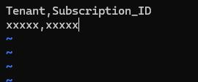

Script execution (Factory-PostgreSQL-CLI-Linux.ps1)
- Open Terminal window
- Change the working directory/folder to the folder PostgreSQL-Info-Gather where the scripts are present.
- Enter the following command in the terminal to execute the info-gather script.
pwsh ./Factory-PostgreSQL-CLI-Linux.ps1

Create support folders (Logs, Output, Downloads etc)
- After triggering the automation all the support folders (Logs, Output, Download etc.) will be created automatically by the automation script in the PostgreSQL-Info-Gather folder
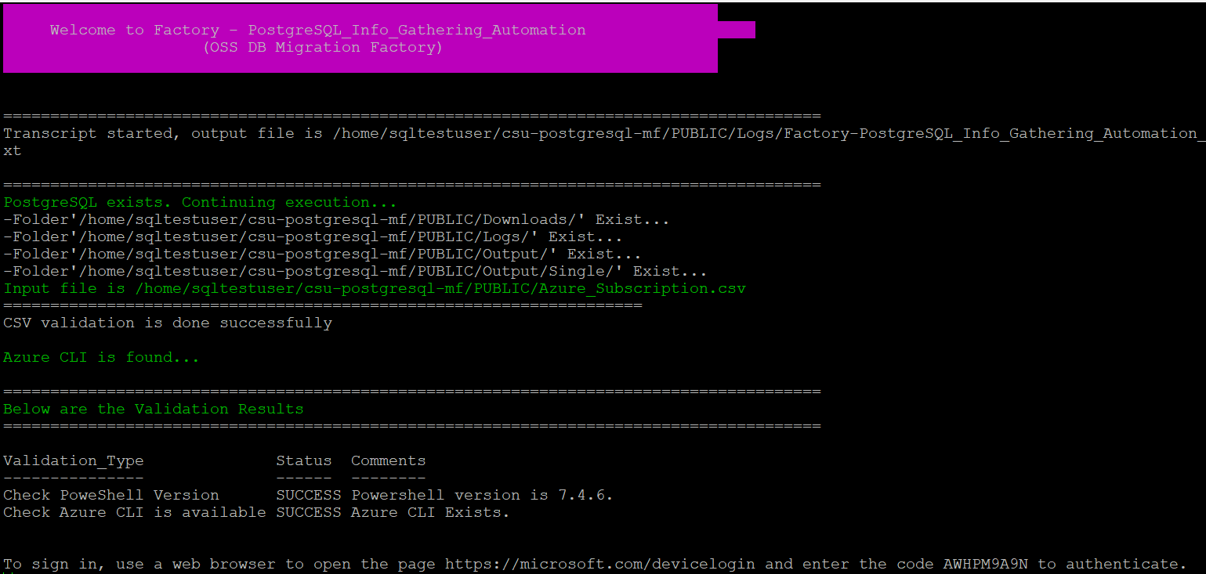
- PowerShell version and Azure CLI are validated.
- Automation script validates if the Azure CLI application is installed. If it is not installed, you will have to install it manually via a link provided on the output screen.
- Automation requires the Azure portal authentication
- Copy the device login URL and code to authenticate

Export Info-Gathering details and generating JSON files
- Once Azure portal authentication is successful, Automation gathers Azure PostgreSQL Single Server details to update them in csv files. Also, Azure CLI’s PostgreSQL commands output will be exported to JSON file.
- The JSON files can be found in the Folder Output Single

Azure PostgreSQL Single Server JSON output
- The Following JSON output file will be generated and contains the list of all Azure PostgreSQL Single Server from the given Azure subscription.
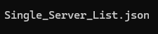

Azure PostgreSQL Single Server CSV output
- CSV files will be generated for all the PostgreSQL Single Server/Instance(s) from the given Azure subscription. Azure CLI’s output are as follows,
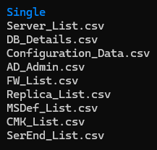

Automation Script Transcript Log
Note: For the Automation, transcript will be generated in text format as shown above

PostgreSQL Server Info-Gathering (Factory-PostgreSQL-Linux.ps1)

Scripts Folder
- Unzip the PostgreSQL-Info-Gather zip file received by Factory Team
Commands: unzip PostgreSQL-Info-Gather.zip
cd PostgreSQL-Info-Gather /
ls -lrt

Preparing the INPUT CSV File -
(Factory-PostgreSQL_Server_Input_file.csv)
- To support the Info Gathering process, INPUT CSV FILE
(Factory-PostgreSQL_Server_Input_file.csv) should be provided with PostgreSQL Server details.
- Provide the Mandatory fields highlighted in red color.

Script execution (Factory-PostgreSQL-Linux.ps1)
- Open terminal window,
- Enter the following command to execute the script.
pwsh ./Factory-PostgreSQL-Linux.ps1
- To perform PostgreSQL server Information gathering, enter option ‘1’.
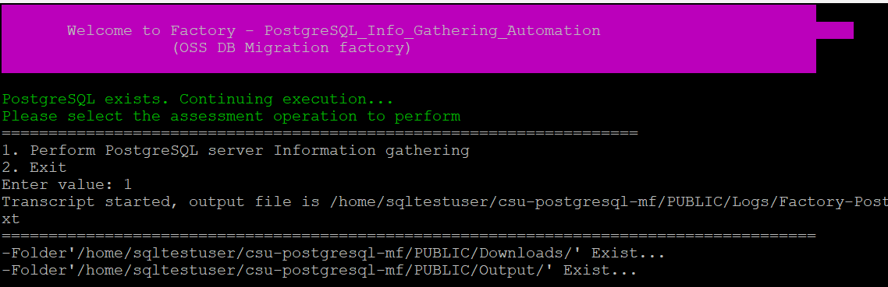
Note: After triggering the automation all the support folders (Logs, Output, Downloads etc.) will be created automatically by the automation script, psql path is validated, and it will ask user to proceed with the execution of the script
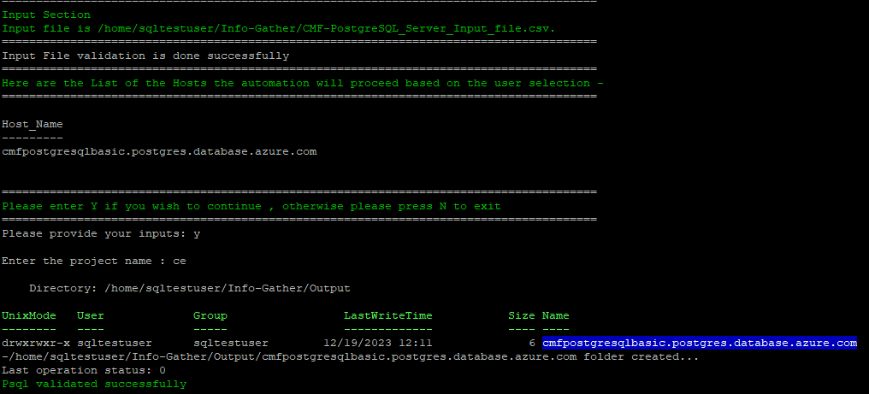
- The script then Validates the list of Hosts to proceed with execution. Continue by Entering “Y” and provide your Project Name. You’ll get below the Final Status of the Script Execution.
Note: Ensure you add the location of psql.exe to your Path environment variables
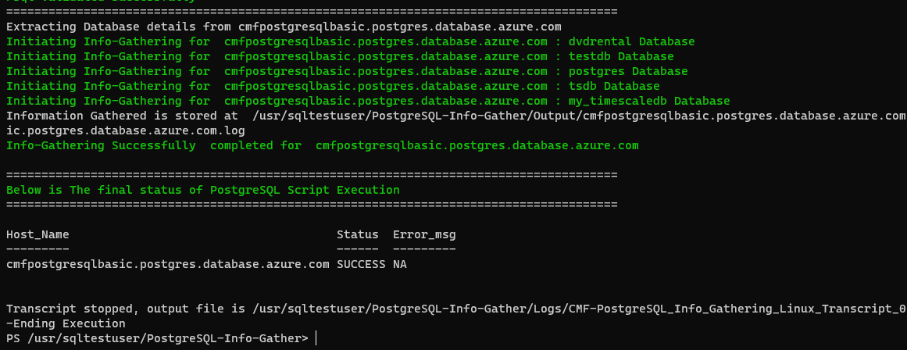

Export Info-Gathering details and generating output log files
- Output log files are generated for each PostgreSQL Server as shown in the below Output Folder.
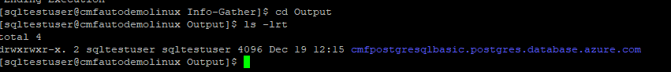
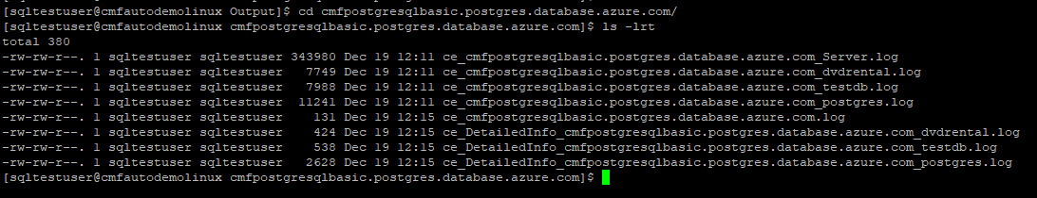

Automation Script Transcript Logs
Note: For the Automation, transcript will be generated in text format as shown above
Note:
- Output files generated using Factory-PostgreSQL-CLI-Linux.ps1 and the log files generated by Factory-PostgreSQL-Linux.ps1 will be in the same Output and Logs folder.
- Please share compressed Output & Logs folder with Factory Team.

PostgreSQL Server Info-Gathering using Azure Cloud Shell
- Click on the icon shown below to open the Azure cloud shell
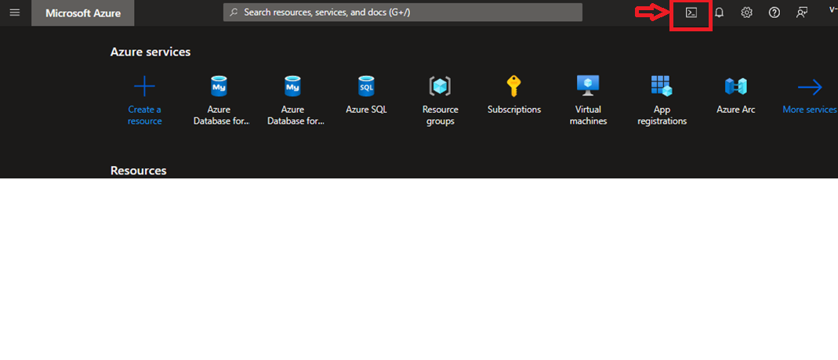
- Click on “Show advanced settings”
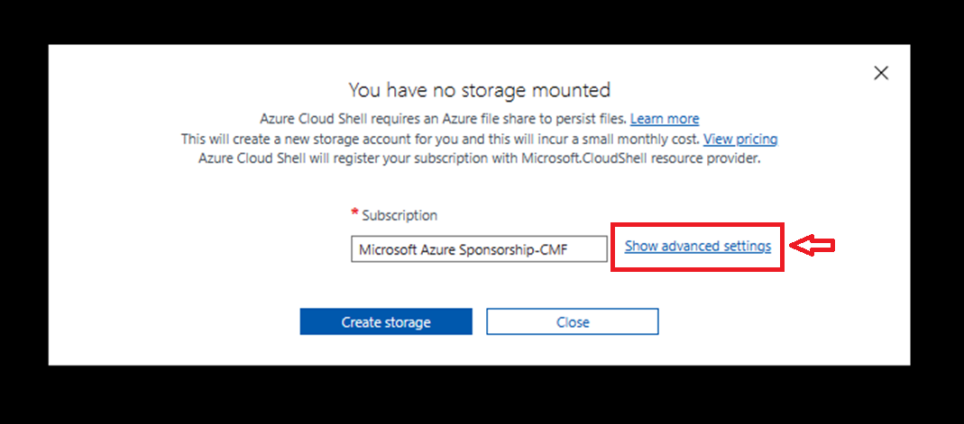
- Choose your preferred region, you can either use existing or create a new resource group for creating the storage account and file share and then click “Create storage”
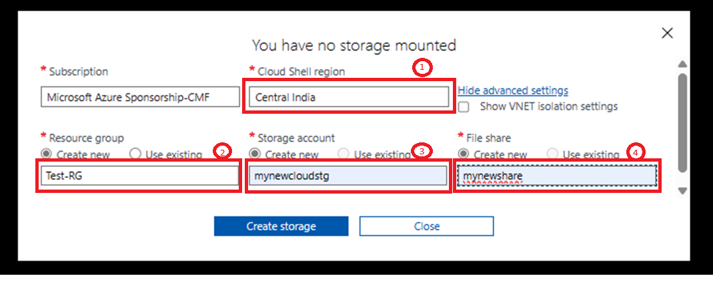

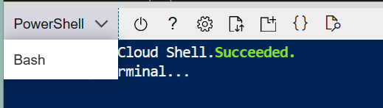
- Choose PowerShell as the Shell.
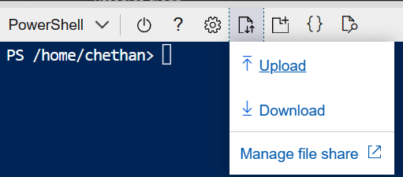
- Upload the PostgreSQL-Info-Gather.zip file.

Scripts Folder
- Unzip the PostgreSQL-Info-Gather zip file received by Factory Team
Commands: unzip PostgreSQL-Info-Gather.zip
ls -lrt

Preparing the INPUT File (Azure_Subscription.csv)
- To support the Info Gathering process, INPUT CSV FILE
(Azure_Subscription.csv) should be provided with appropriate details.
- Open the Cloud Shell editor to edit the csv file.
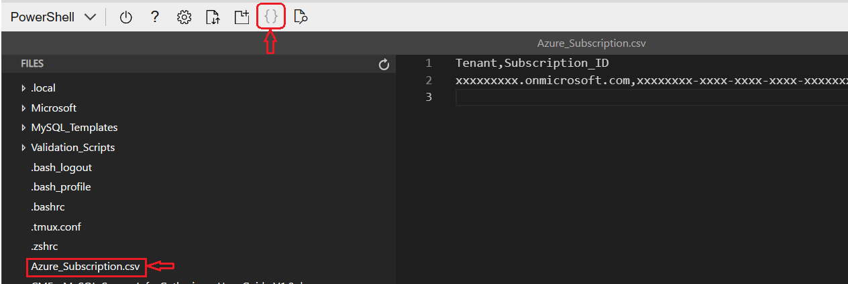

- In Azure_Subscription.csv file, provide the Tenant and Subscription ID.
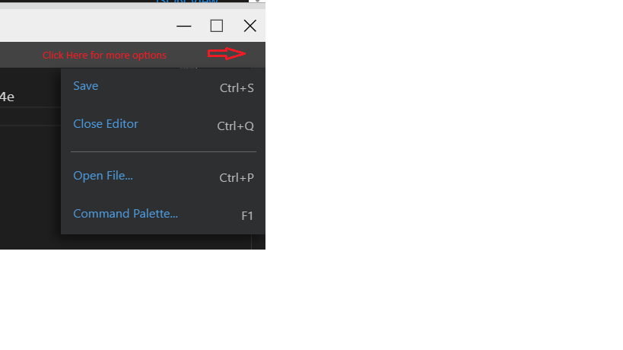
- Save and close the editor.

Script execution (Factory-PostgreSQL-Linux.ps1)
- Enter the following command to execute the script.
./Factory-PostgreSQL-CLI-Linux.ps1
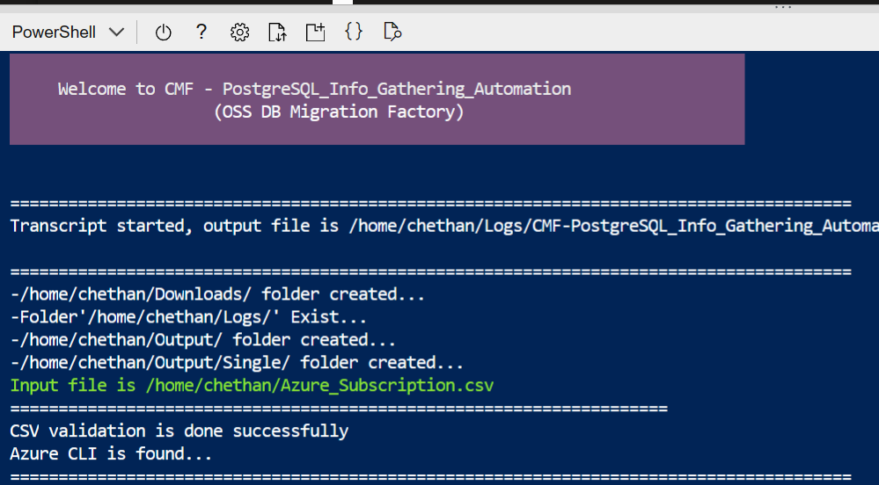
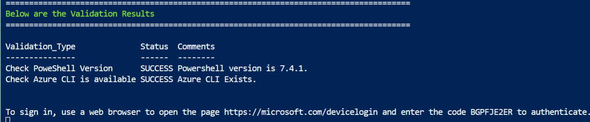
- Copy the device login URL and code to authenticate
- Output is as shown below.
- Open the Cloud Shell editor to edit the Factory-PostgreSQL_Server_Input_file.csv file.
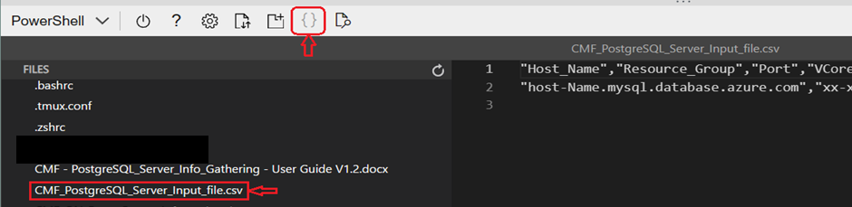
- In Factory-PostgreSQL_Server_Input_file.csv file, provide the password and Approval Status.
Note: Password can also be provided during script execution.
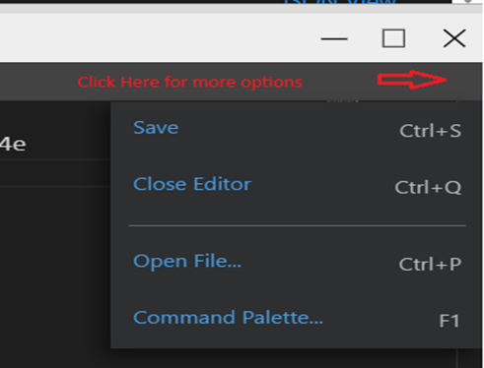
- Save and close the editor.

- Run the below script for PostgreSQL Server Info Gathering
./Factory-PostgreSQL-Linux.ps1
- To perform PostgreSQL server Information gathering, enter option ‘1’. 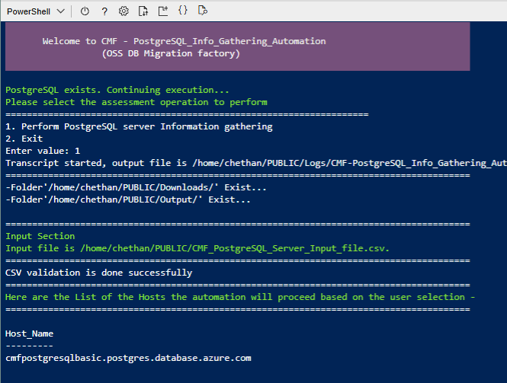

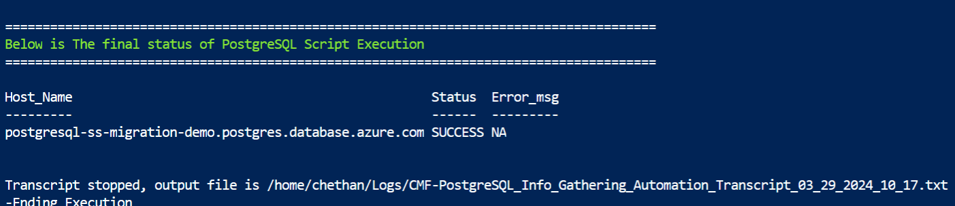
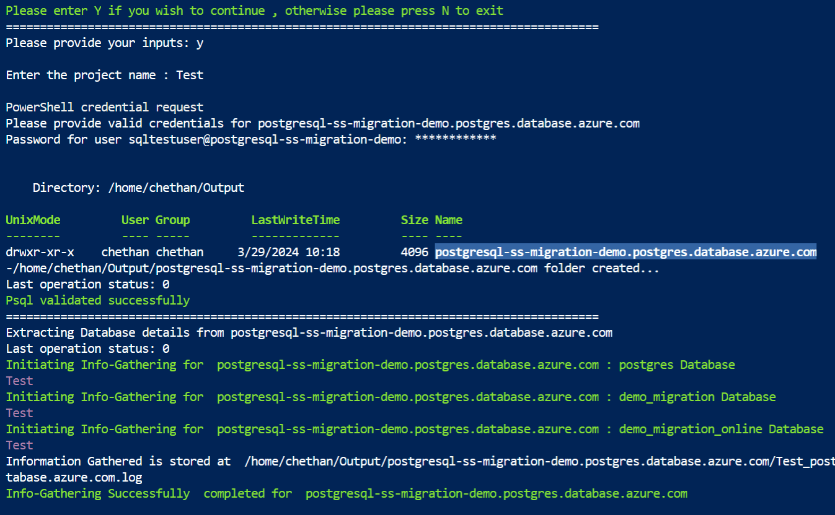

- Zip the Output and Logs folder, download and share it with the Factory Team using the commands below.
zip -r filename.zip ./Logs ./Output
- To download the zip files –

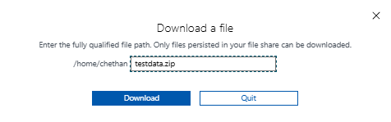
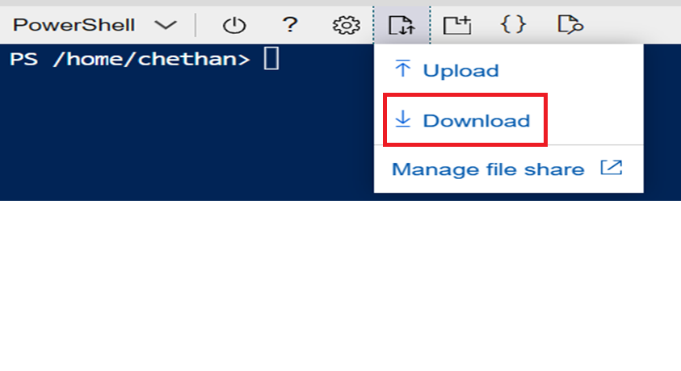

Appendix

Checking Error Logs
- If script execution fails due to some errors, for example, “incorrect password” then you can check the detailed error log in Output folder Server_name folder ce_postgresqlxxx.postgres.database.azure.com.log file.
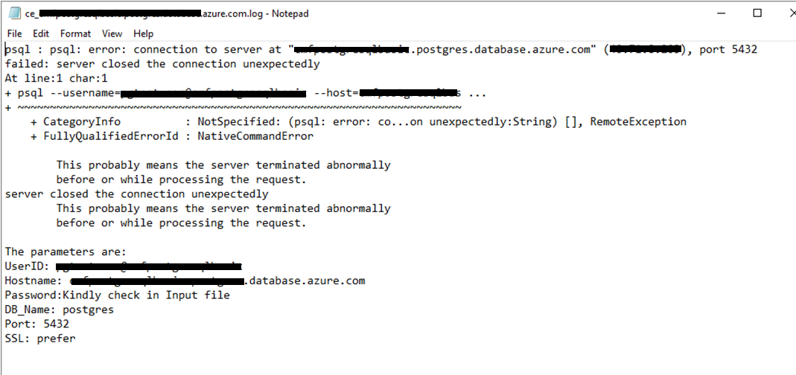

Troubleshooting
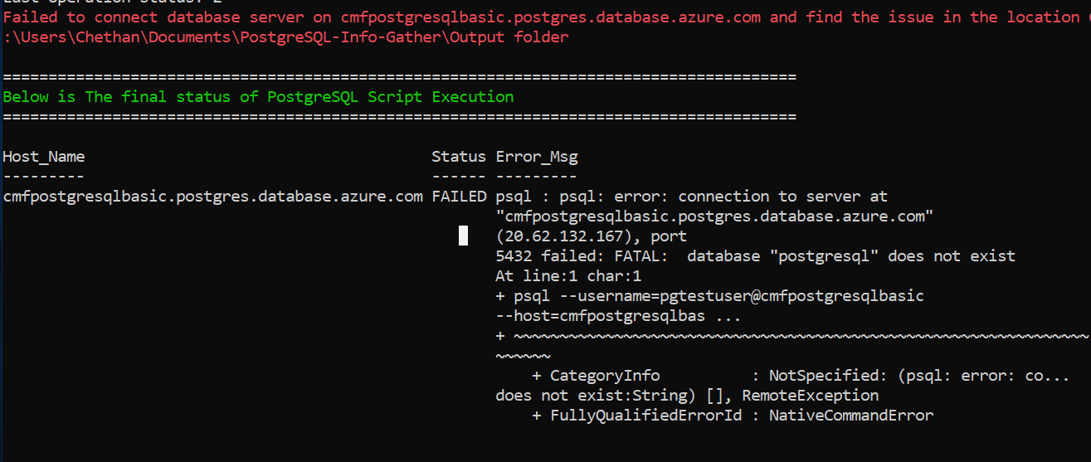
- In the Factory_PostgreSQL_Server_Input_file.csv file, ensure that the “DB_Name” column value is “postgres”.

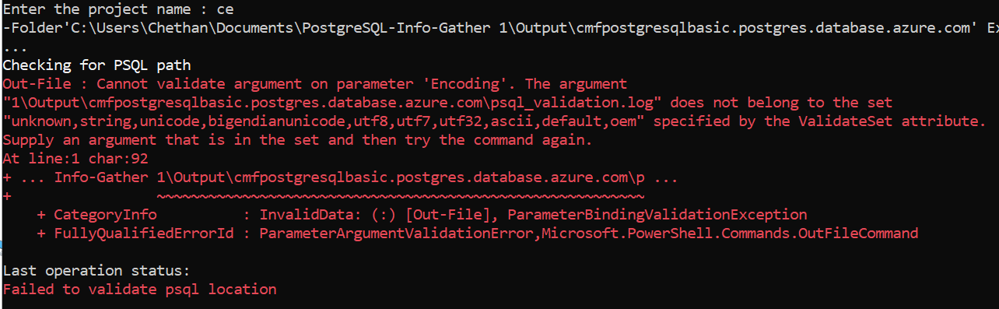

- Ensure that the scripts folder name does not contain any whitespaces. In the above example, the scripts folder name contains whitespaces “PostgreSQL-Info-Gather 1”.

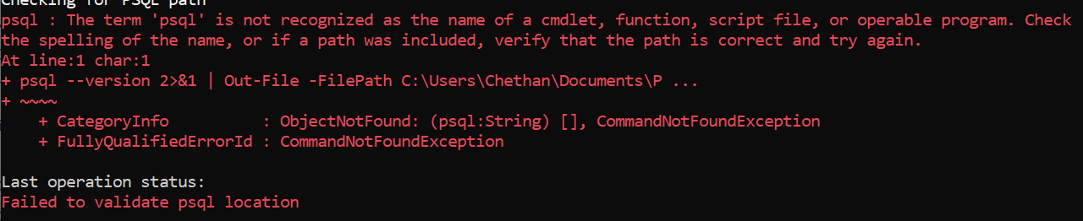
- Add the PostgreSQL server binary path in environment variables. Refer below link for steps.
Adding psql (Postgres) as an environment variable in Windows

Input CSV File – Azure_Subscription.csv

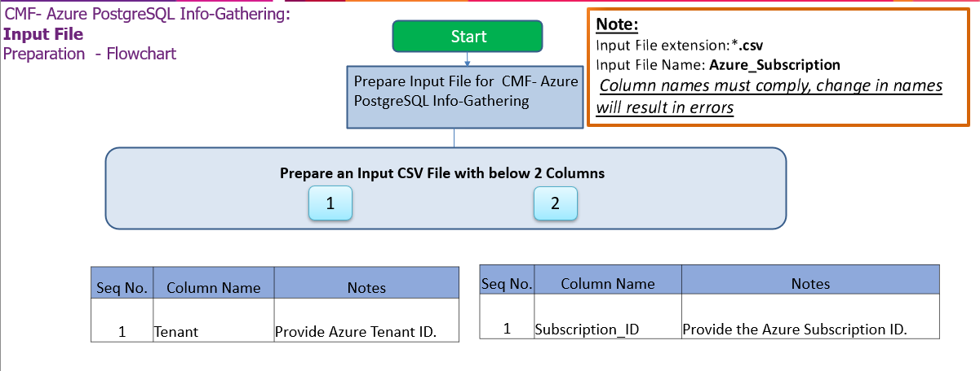

Important Notes:
    - This script is based on the csv file named ‘Azure_Subscription’ and the following columns in the Input csv file
    - INPUT CSV FILE name must be Azure_Subscription.csv
    - Column Name must be kept as shown below, change in names will result in errors
    - Values in the column must be correct, incorrect values will also result in errors
Seq.No | File | Note
1 | 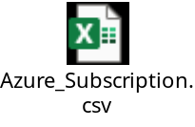 | Sample: Azure_Subscription.csv

Input CSV File - Factory-PostgreSQL_Server_Input_file.csv
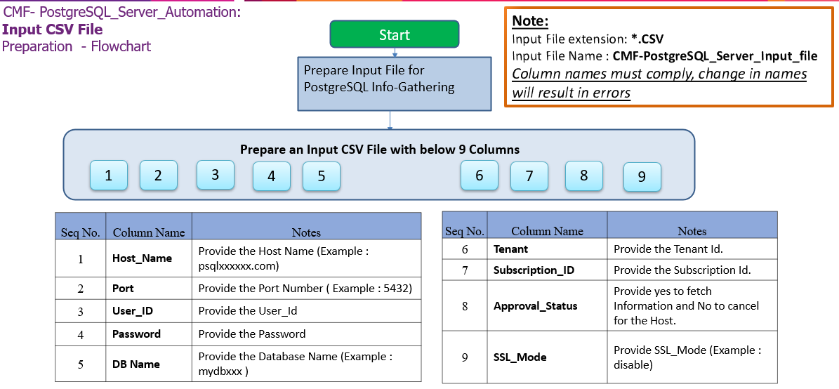 Important Notes:
    - PostgreSQL Client is required to establish Connectivity to PostgreSQL Servers.
    - This script is based on the CSV file named ‘Factory-PostgreSQL_Server_Input_file.csv’.
    - Column Name must be kept as shown below, change in names will result in errors
    - Values in the column must be correct, incorrect values will also result in errors
    - Tenant and Subscription_ID columns are Optional.
    - Password field is optional but should be provided during script execution if omitted.

- Columns for Input File: Factory-PostgreSQL_Server_Input_file.csv
Column Name | Note
Host_Name | Provide the Host Name (Example : localhost)
Port | Provide the Port Number ( Example : 5432)
VCore | Provide the Number of VCore (Optional)
Auth_Type | Provide the Authentication Type(Optional)
User_ID | Provide the User_Id
Password | Provide the Password
DB_Name | Provide the Database Name (Example : postgres )
Tenant | Provide the Tenant Id. (Optional)
Subscription_ID | Provide the Subscription Id. (Optional)
Approval_Status | Provide yes to fetch Information and No to cancel for the Host.
SSL_Mode | Provide SSL_Mode (Example : require)
Seq.No | File | Note
1 | 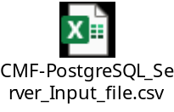 | Sample:  Factory-PostgreSQL_Server_Input_file.csv

- Internet access to the URLs below:
URL | Note
https://aka.ms/installazurecliwindows | Azure CLI (Windows)
https://learn.microsoft.com/en-us/cli/azure/install-azure-cli-linux?pivots=dnf | Azure CLI (Linux)
https://aka.ms/PSWindows | PowerShell (Windows)

Without Internet access to the URLs
Follow the instructions in the following sections to download all the software manually to a server where internet connectivity is enabled. Once all the software is downloaded, move all of it to the server where PostgreSQL Automation script will be executed and install all of them one by one.

Installing Azure CLI for Windows and Linux
Windows - https://aka.ms/installazurecliwindows
Linux - https://learn.microsoft.com/en-us/cli/azure/install-azure-cli-linux

PowerShell Version & Execution policy
Execute the below commands from windows PowerShell as Administrator.
To find the PowerShell Version
- Get-Host
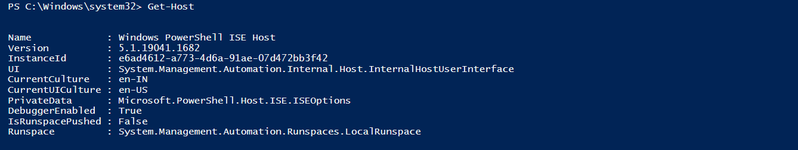
Set the PowerShell execution policy
- Set-ExecutionPolicy Unrestricted -Scope CurrentUser

PowerShell Installation on Linux
- Register the Microsoft RedHat Repository

curl https://packages.microsoft.com/config/rhel/7/prod.repo | sudo tee /etc/yum.repos.d/microsoft.repo

- Install PowerShell

sudo yum install –assume yes powershell

- Start PowerShell

Pwsh

Adding psql (Postgres) as an environment variable in Windows
- To add the PostgreSQL Client to your environment path, you'll need to modify the system's PATH environment variable to include the directory where the PostgreSQL Client is located. Below are the steps to add the psql client to the system env path,

- After the installation, open Start menu, search for Environment variables and select “Edit the system Environment variables”

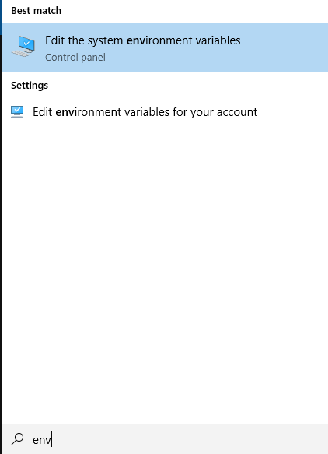

- In the System Properties window, click the “Environment variables”

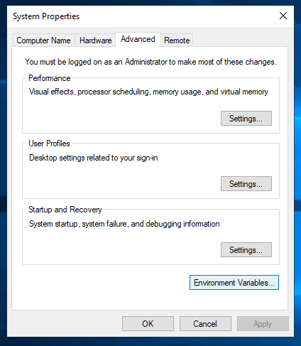

- Next, in the Environment variables window, under “System variables” section, select Path and click “Edit”

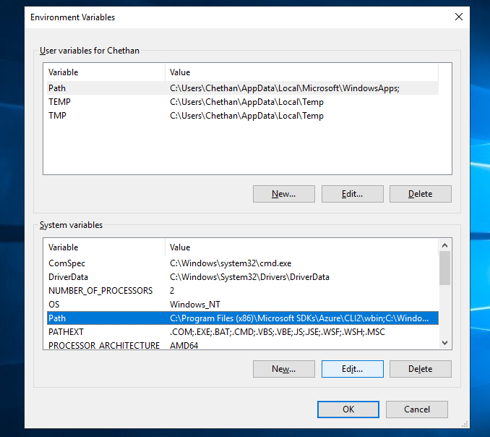
- Click the “New” button and add the installation path or Browse to navigate and add the PostgreSQL Client installation directory path (e.g. C:\Program Files\PostgreSQL\16\bin or the path where PostgreSQL Client is installed) as shown below

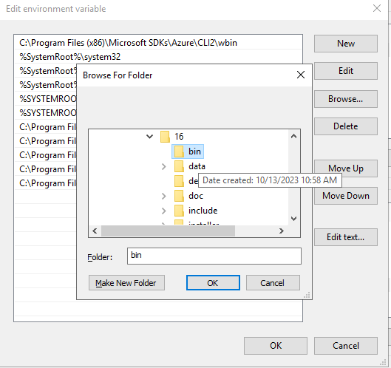

- Click “OK” to close each window.

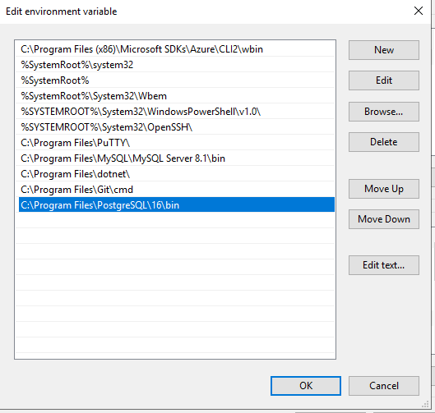
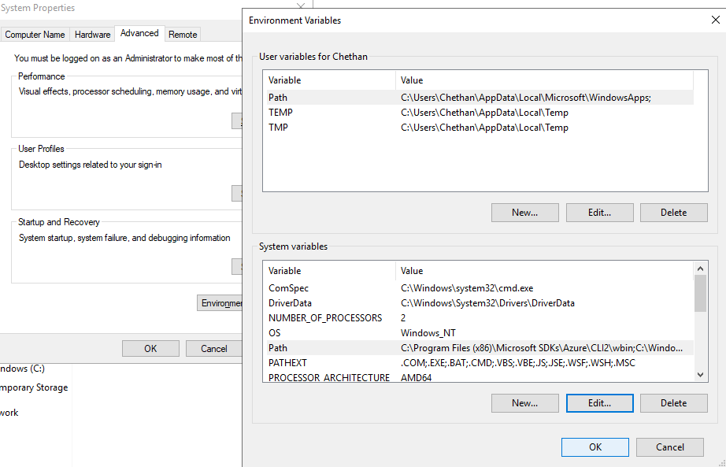

Adding Azure CLI as an environment variable in Windows
- To add the Azure CLI to your environment path, follow the steps below,

- After installation, open the Start menu, search for "Environment Variables," and select "Edit the system environment variables."

- In the System Properties window, click the "Environment Variables" button.

- In the Environment Variables window, under the "System variables" section, find and select the "Path" variable, then click the "Edit" button.

- Click the "New" button and add the path to the Azure CLI installation directory (e.g., C:\Program Files\Microsoft SDKs\Azure\CLI2\wbin).

- Click "OK" to close each window.

- Verify by opening a new Command Prompt or PowerShell window and type “az” to verify that the Azure CLI is now accessible.

